Which of the following options correctly prints the phrase “Hurry Up!!”?

 printf(“Hurry Up!!”)

 print(Hurry Up!!!)

 print_sentence(Hurry Up!!!)

 print(“Hurry Up!!”)

***1 point***

What is the output of the following code snippet?  
  
    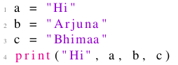

 Hi Arjuna Bhimaa

 Hi Arjuna Hi Bhimaa

 Hi Hi Arjuna Bhimaa

 Hi Arjuna Bhimaa Hi

***1 point***

With what extension are the python files saved?

 .p

 .python

 .pyn

 .py

***1 point***

Which of the following statements correctly represents taking input from user in python?

 a=get("Enter the value")

 a=inp("Enter the value")

 a=input("Enter the value")

 None of the above

***1 point***

What is the output of the following code?  
  
    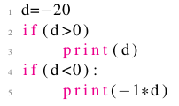

 -20

 Syntax error

 20

 Displays nothing

***1 point***

What does the following code do?  
  
    

 displays numbers from 0 to 4

 displays numbers from 1 to 5

 displays numbers from 0 to 5

 none of the above

***1 point***

What does the following code do?  
  
    

 displays table of 2

 syntax error

 displays table of 10

 none of the above

***1 point***

What does the following code do?  
  
    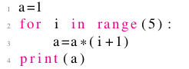

 24

 0

 120

 none of the above

***1 point***

What is the output of the following code?  
  
    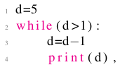

 4 3 2 1

 5 4 3 2 1

 4 3 2 1 0

 5 4 3 2 1 0

***1 point***

What is the output of the following code?  
  
    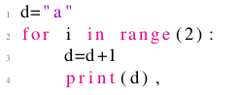

 a b c

 a b

 b c

 Error